Willyta Asmara Diya Abadi (19051397017)
D4 MI A

PEMODELAN SISTEM

- Diagram Konteks
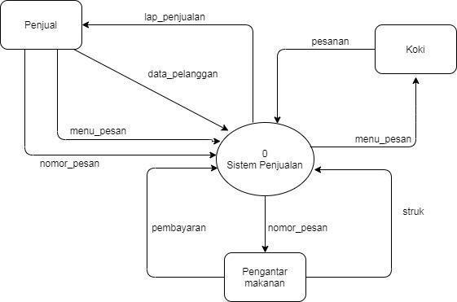

- Diagram Level 1
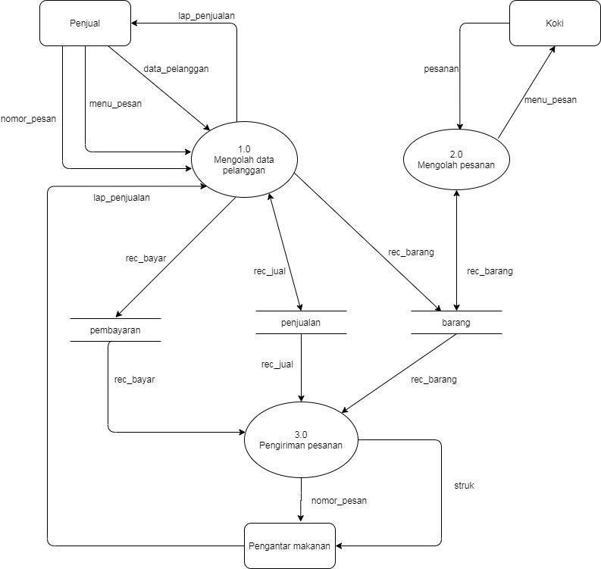

- Diagram Level 2 Proses Data Pesanan
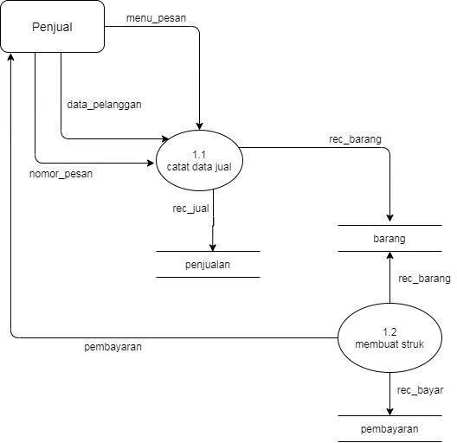

- Diagram Level 2 Proses Pengolahan
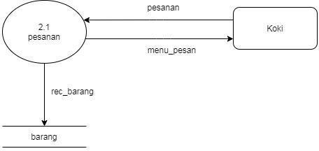

- Diagram Level 2 Proses Pengiriman
